Transforming Graphs

1. Investigating adding constants to a function

Consider the function y = f(x) where f(x) = x² as shown in the first graph here. Use your graphic calculator to help sketch each of the following three functions. Use the ‘TRACE’ function to find the crossing points and mark them on your sketch.

f(x) = x² f(x) + 2 = x² + 2
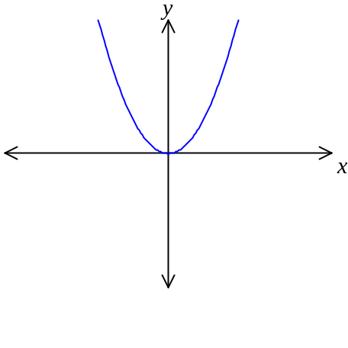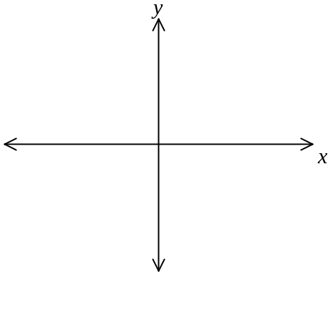

f(x) – 3 = x² – 3 f(x) + 4 = x² + 4

What is happening to the graph in each case? Use the space below to write down your answer.

2. Investigating adding constants within a function

Consider the function y = f(x) where f(x) = x² as shown in the first graph here. Use your graphic calculator to help sketch each of the following three functions. Use the ‘TRACE’ function to find the crossing points and mark them on your sketch.

f(x) = x² f(x + 2) = x² + 4x + 4

f(x – 3) = x² – 6x + 9 f(x + 4) = x² + 8x + 16

What is happening to the graph in each case? Use the space below to write down your answer.

3. Investigating multiplying a function by a constant

Consider the function y = f(x) where f(x) = 0.5x³ – x² as shown in the first graph here. Use your graphic calculator to help sketch each of the following three functions.

f(x) = 0.5x³ – x² 2f(x) = x³ – 2x²
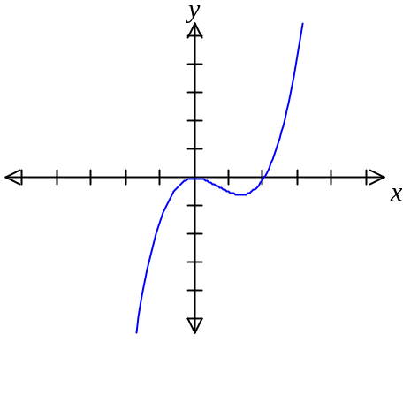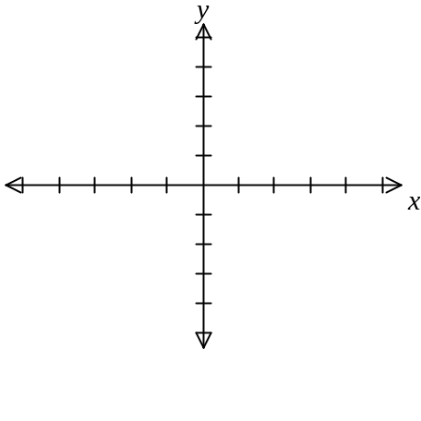

6f(x) = 3x³ – 6x² 3f(x) = 1.5x³ – 3x²

What is happening to the graph in each case? Use the space below to write down your answer.

4. Investigating multiplying by a constant within the function

Consider the function y = f(x) where f(x) = x³ – 2x² as shown in the first graph here. Use your graphic calculator to help sketch each of the following three functions. Mark on any crossing points.

f(x) = x³ – 2x² f(2x) = 8x³ – 8x²
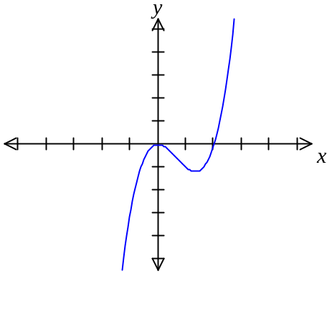

f(3x) = 27x³ – 18x² f(½x) = (½x)³ – 2(½x)² [ = 0.125x³ – 0.5x²]

What is happening to the graph in each case? Use the space below to write down your answer.

